**Student Name: Ashley Elliott**

**Access Code (located on the underside of the lid of your lab kit): AC-2JZCY3X**

**Pre-Lab Questions”**

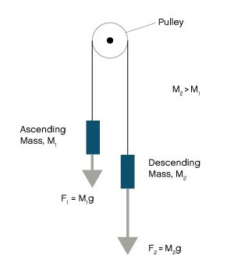Use the free body diagram of the pulley (Figure 4) to answer the Pre-Lab Questions.

***Figure 4: Free Body Diagram: 2 objects with mass hanging on a pulley by string.***

1. Draw a free body diagram for M1. Handwrite your name next to your diagram.

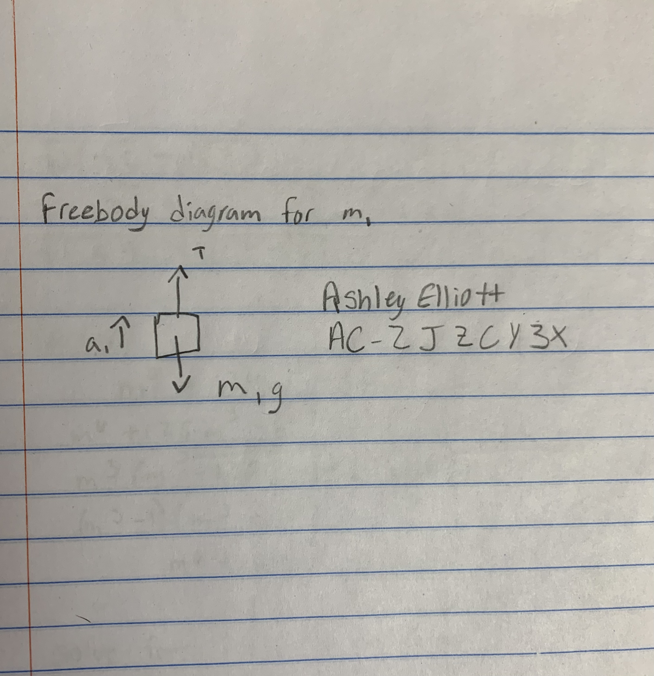

1. Draw a free body diagram for M2. Handwrite your name next to your diagram.

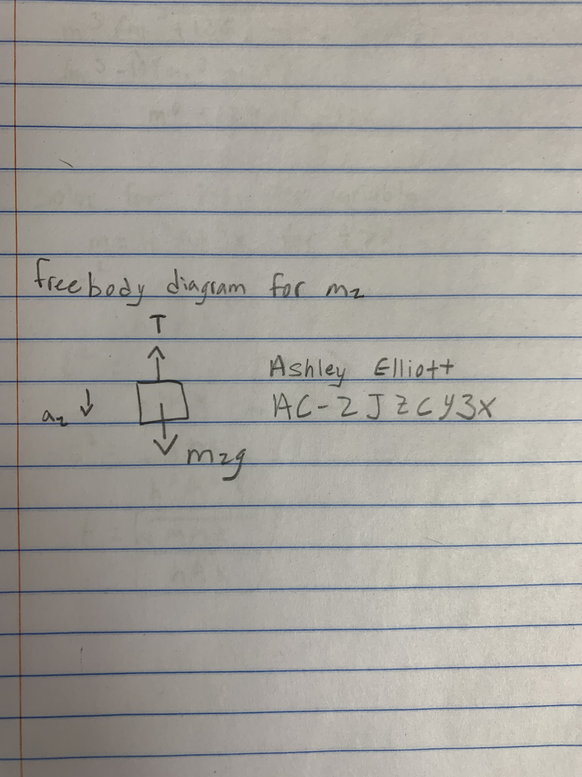

1. Apply Newton’s 2nd Law to write the equations for M1 and M2. You should get two equations with Tension in the string, weight for each mass and accelerations for each mass (a1 and a2).  
   **m1 --> T-m1g. m2 --> m2g-T= m2a1**
2. This results in two equations with three unknowns! A third equation is required to solve the system. What is the third equation? (Hint: What is the relationship between a1 and a2?)  
   **The masses are connected to each other via the string, that means the accelerations are equal to each other so a1=a2**

# **EXPERIMENT 1: NEWTON’S FIRST LAW OF MOTION**

Data Table

Table 1. Motion of Water Observations

|  |  |
| --- | --- |
| **Motion** | **Observations** |
| **a** | **I waited for the water in the cup to still and then picked up the cup and moved it quickly to the left. The water in the cup moved up towards the right and spilled on my hand and the floor. Once the cup was at rest the water moved back and forth and gradually stopped.** |
| **b** | **At first the water moved back in the cup very slightly then was calm and constant while I walked.** |
| **c** | **When I turned right, the water splashed up on to my hand and spilled.** |
| **d** | **When I quickly stopped the water continued to move forward in the cup then rocked back towards me, and so forth until it came to rest.** |

Table 2. Observations after Flicking Notecard Off of Cup

|  |  |
| --- | --- |
| **Trial** | **Observations** |
| **1** | **When I flicked the notecard the washer fell into the cup and made a little splash up.** |
| **2** | **My results were the same as trial 1** |
| **3** | **My results were the same as trial 1** |
| **4** | **My results were the same as trial 1** |
| **5** | **My results were the same as trial 1, each time the washer fell into the cup and there was a slight splash** |

## Post-Lab Questions

1. Explain how your observations of the water and washer demonstrate Newton’s law of inertia.   
   **Newton’s Law of inertia states that every object will stay at rest or in uniform motion continuing in a straight line unless it is changed by the action of an outside force. Using this we can determine that the washer would continue to stay at rest on the card until an outside force (me) removed the card causing the washer to fall because nothing was holding it up. Likewise, the water wanted to stay in place when it was at rest, but when an outside force (me) abruptly changed direction by either stopping or accelerating in a different direction, the water was then in motion.**
2. Draw a free body diagram of your containers of water from the situation in Part 1 Step 4d. Draw arrows for the force of gravity, the normal force (your hand pushing up on the container), and the stopping force (your hand accelerating the container as you stop.) What is the direction of the water’s acceleration?   
     
   Handwrite your name next to your diagram.

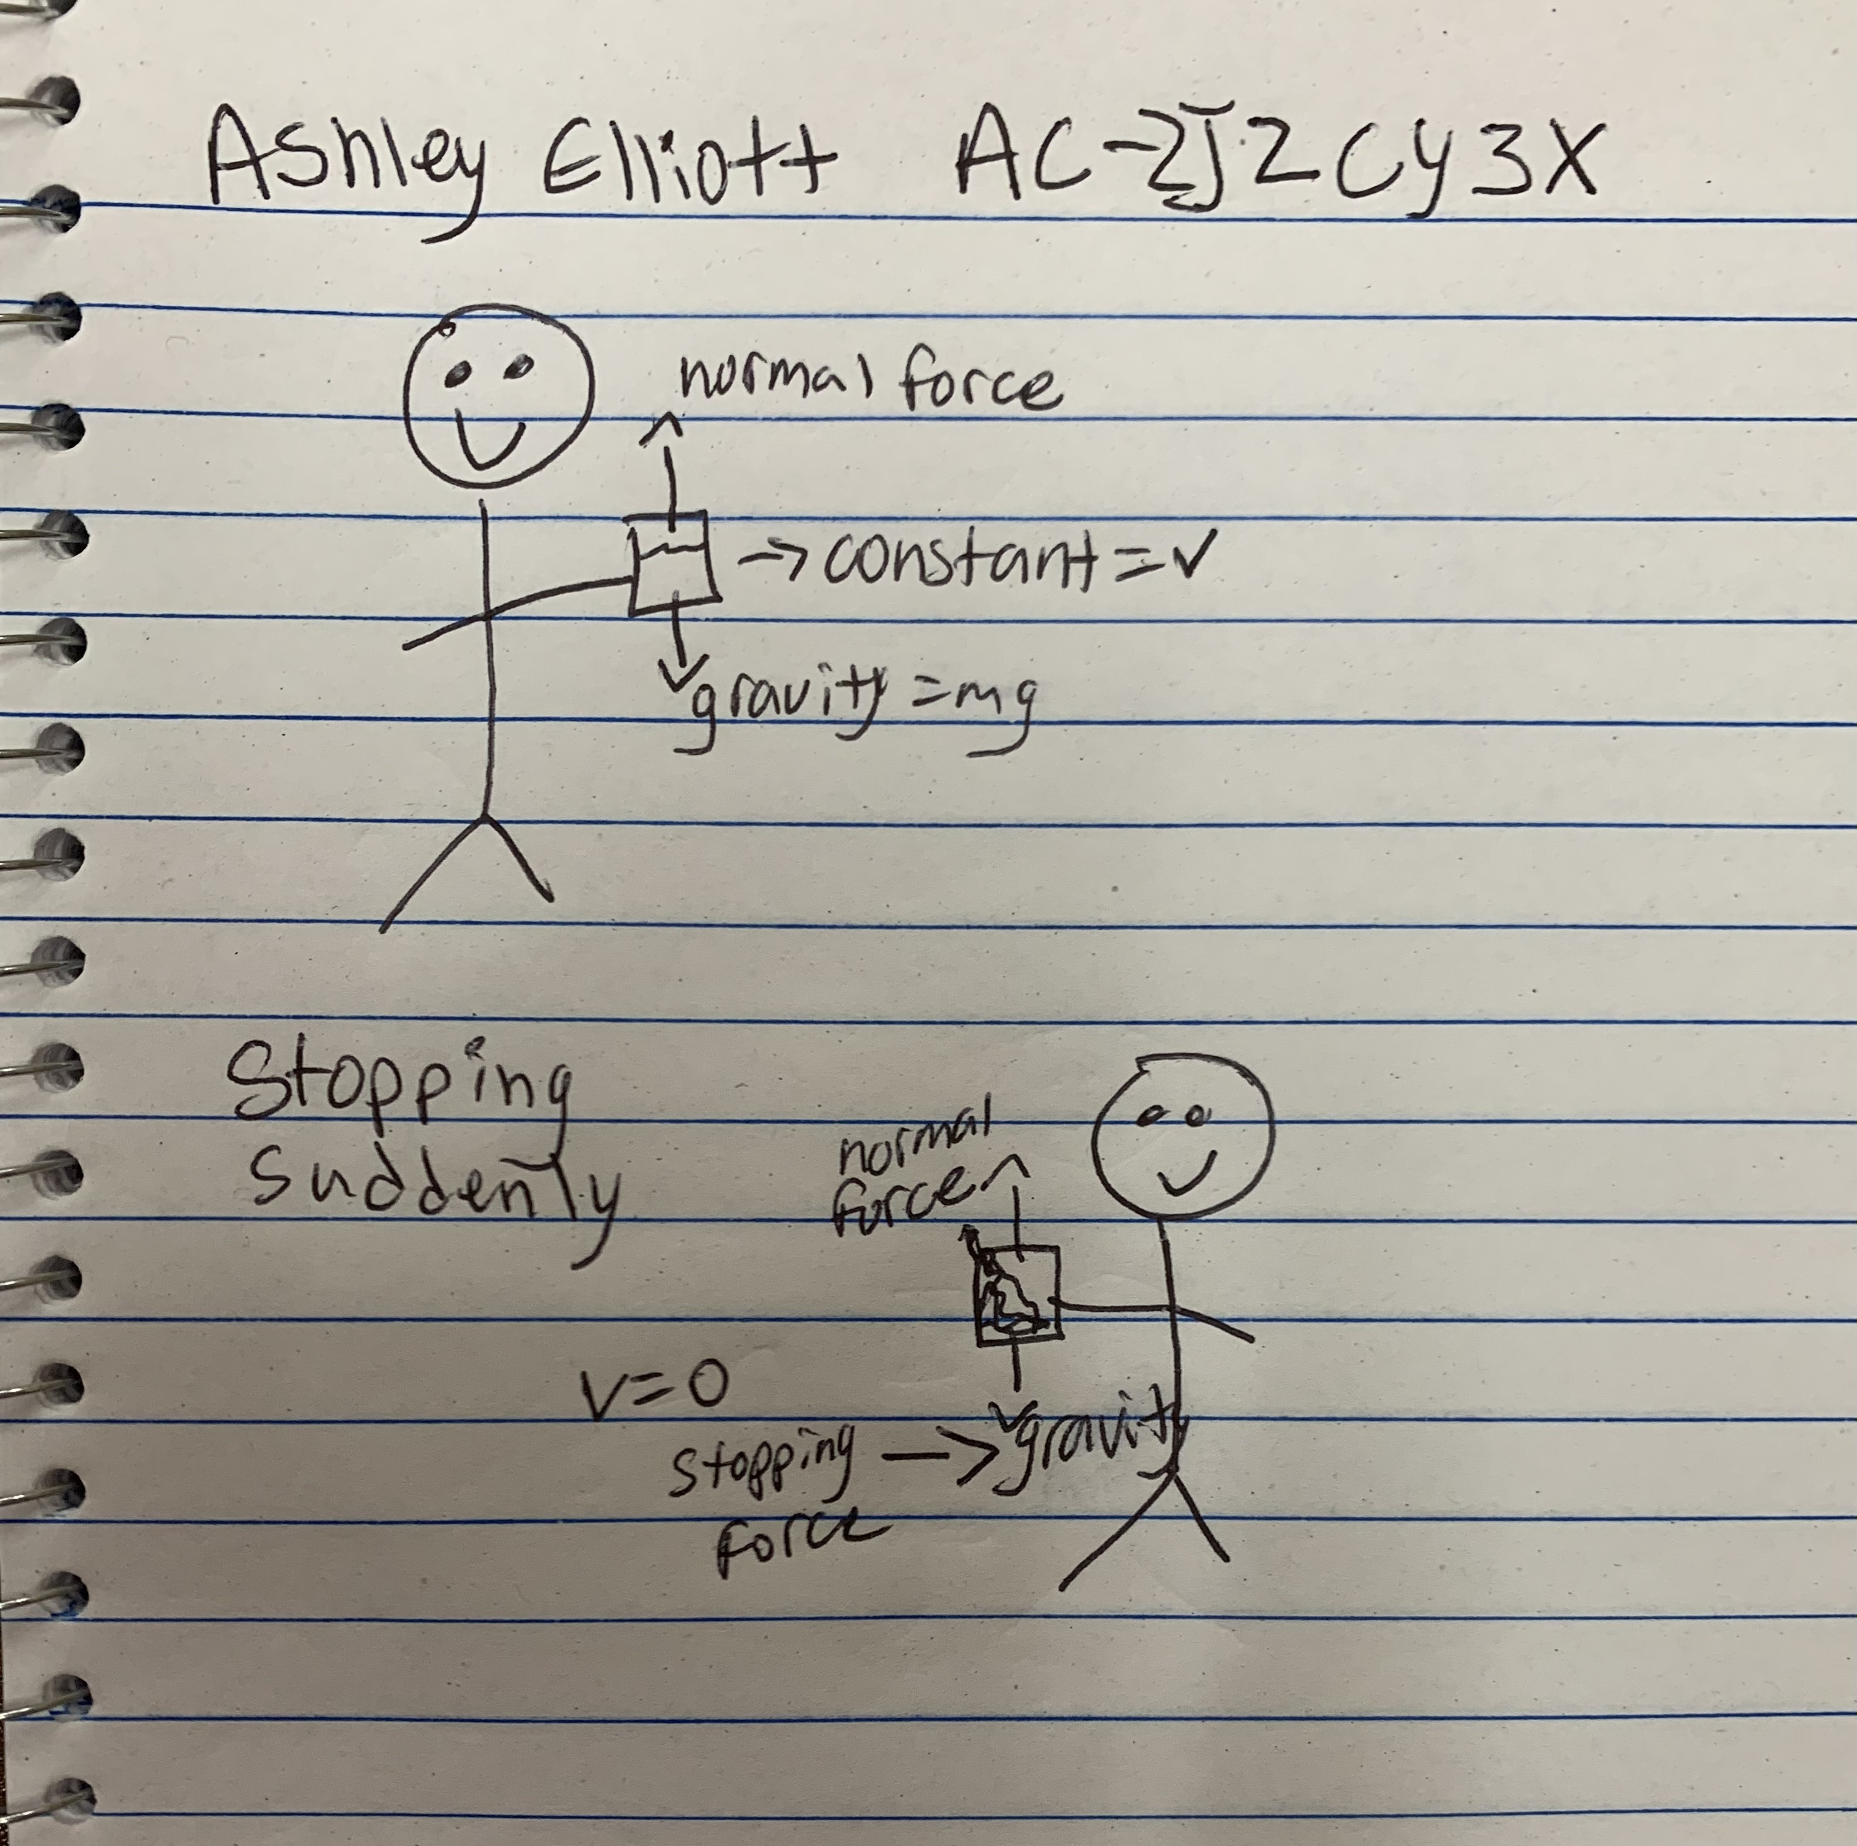

1. Can you think of any instances when you are driving or riding a car that are similar to this experiment? Describe two instances where you feel forces in a car in terms of inertia.   
   **When driving I need to accelerate to get moving and I can feel my body press back into my seat until the inertia decreases and then I will no longer feel myself being pressed back into the seat. Once the car and myself/any passengers in the car are traveling at the same relative motion, we will no longer be able to feel any outside forces.**

# **EXPERIMENT 2: Newton’s third law and force pairs**

Data Table

Table 3. Forces on a Stationary Spring

|  |
| --- |
| **Force on Stationary 10 N Spring Scale (N)** |
| **5.4 N** |
| **Force on Stationary 5N Spring Scale (N)** |
| **5.0 N** |

Table 4. Spring Scale Force Data

|  |  |  |
| --- | --- | --- |
| **Suspension Set Up** | **Force (N) on 10 N Spring Scale** | **Force (N) on 5 N Spring Scale** |
| **0.5 kg Mass on 10 N Spring Scale** | **5 N** |  |
| **0.5 kg Mass with String on 10 N Spring Scale** | **5 N** |  |
| **0.5 kg mass, string and 5 N Spring Scale on 10 N spring scale** | **5.5 N** | **5 N** |
| **0.5 kg mass, string and 5 N Spring Scale on 10 N spring scale on Pulley** | **5.5 N** | **5 N** |

## Post-Lab Questions

1. How did the magnitude of the forces on both spring scales compare after you moved the 10 N spring scale?  
   **I read both spring scales at 5 N.**
2. How did the magnitude of the forces on both spring scales compare after you move the 5 N spring scale?  
   **The spring scales read at about 5 N.**
3. Use Newton’s 3rd Law to explain your observations in Questions 1 and 2.  
   **Newton’s 3rd law says that every action (force) has an equal and opposite reaction and it does not matter which scale is used to read this and where the mass is located, the scale readings will be the same.**
4. Compare the force on the 10 N spring scale when it was directly attached to the 0.5 kg mass and when there was a string between them.  
   **I did not notice any difference because of the string. It weighs so little that it did not affect my final readings.**
5. Compare the force on the two spring scales in Steps 5 and 6. What can you conclude about the tension in a string?   
   **The string tension as well as the mass were equal**

**Take a photo of your pulley, spring scales, and 0.5kg mass setup (should look like Figure 6) . Be sure to have your name handwritten in the background of the photo.**   
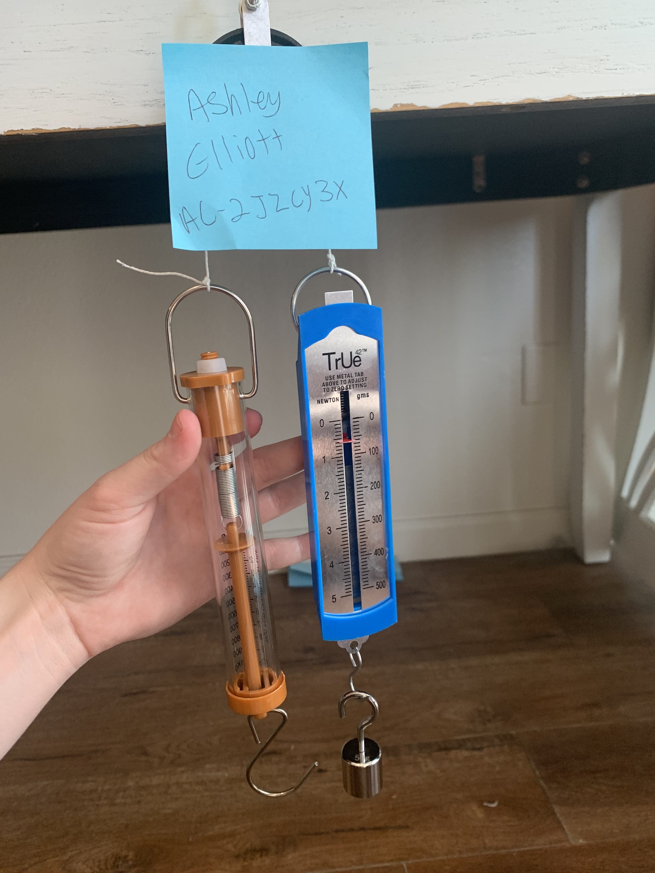

# **EXPERIMENT 3: Newton’s second law and the atwood**

Data Table

Table 5. Motion Data

|  |  |  |  |
| --- | --- | --- | --- |
| **Mass of 15 Washers (kg)** | **0.05 kg** | **Average Mass of Washer (kg)** | **0.003 kg** |
| **Procedure 1** | | | |
| **Height (m): 0.65 m** | | | |
| **Trial** | | **Time (s)** | |
| **1** | | **2.49** | |
| **2** | | **2.57** | |
| **3** | | **2.55** | |
| **4** | | **2.52** | |
| **5** | | **2.59** | |
| **Average** | | **2.54** | |
| **Average Acceleration (m/s2)** | | **2.54m/s^2** | |
| **Procedure 2** | | | |
| **Height (m): .7 m** | | | |
| **Trial** | | **Time (s)** | |
| **1** | | **2.74** | |
| **2** | | **2.45** | |
| **3** | | **2.56** | |
| **4** | | **2.5** | |
| **5** | | **2.36** | |
| **Average** | | **2.52** | |
| **Average Acceleration (m/s2)** | | **2.52 m/s^2** | |

## Post-Lab Questions

1. When you give one set of washers a downward push, does it move as easily as the other set? Does it stop before it reaches the floor? How do you explain this behavior?

**No, the set of washers that were heaviest did not move as easily and they did stop before they reached the floor. This can be explained because they are directly proportional, the larger mass would have more resistance.**

1. Draw a free body diagram for M1 and M2 in each procedure (Procedure 1 and Procedure 2). Draw force arrows for the force due to gravity acting on both masses (Fg1 and Fg2) and the force of tension (FT). Also draw arrows indicating the direction of acceleration, *a*.  
     
     
     
     
     
     
     
     
     
     
   Handwrite your name next to your diagram.

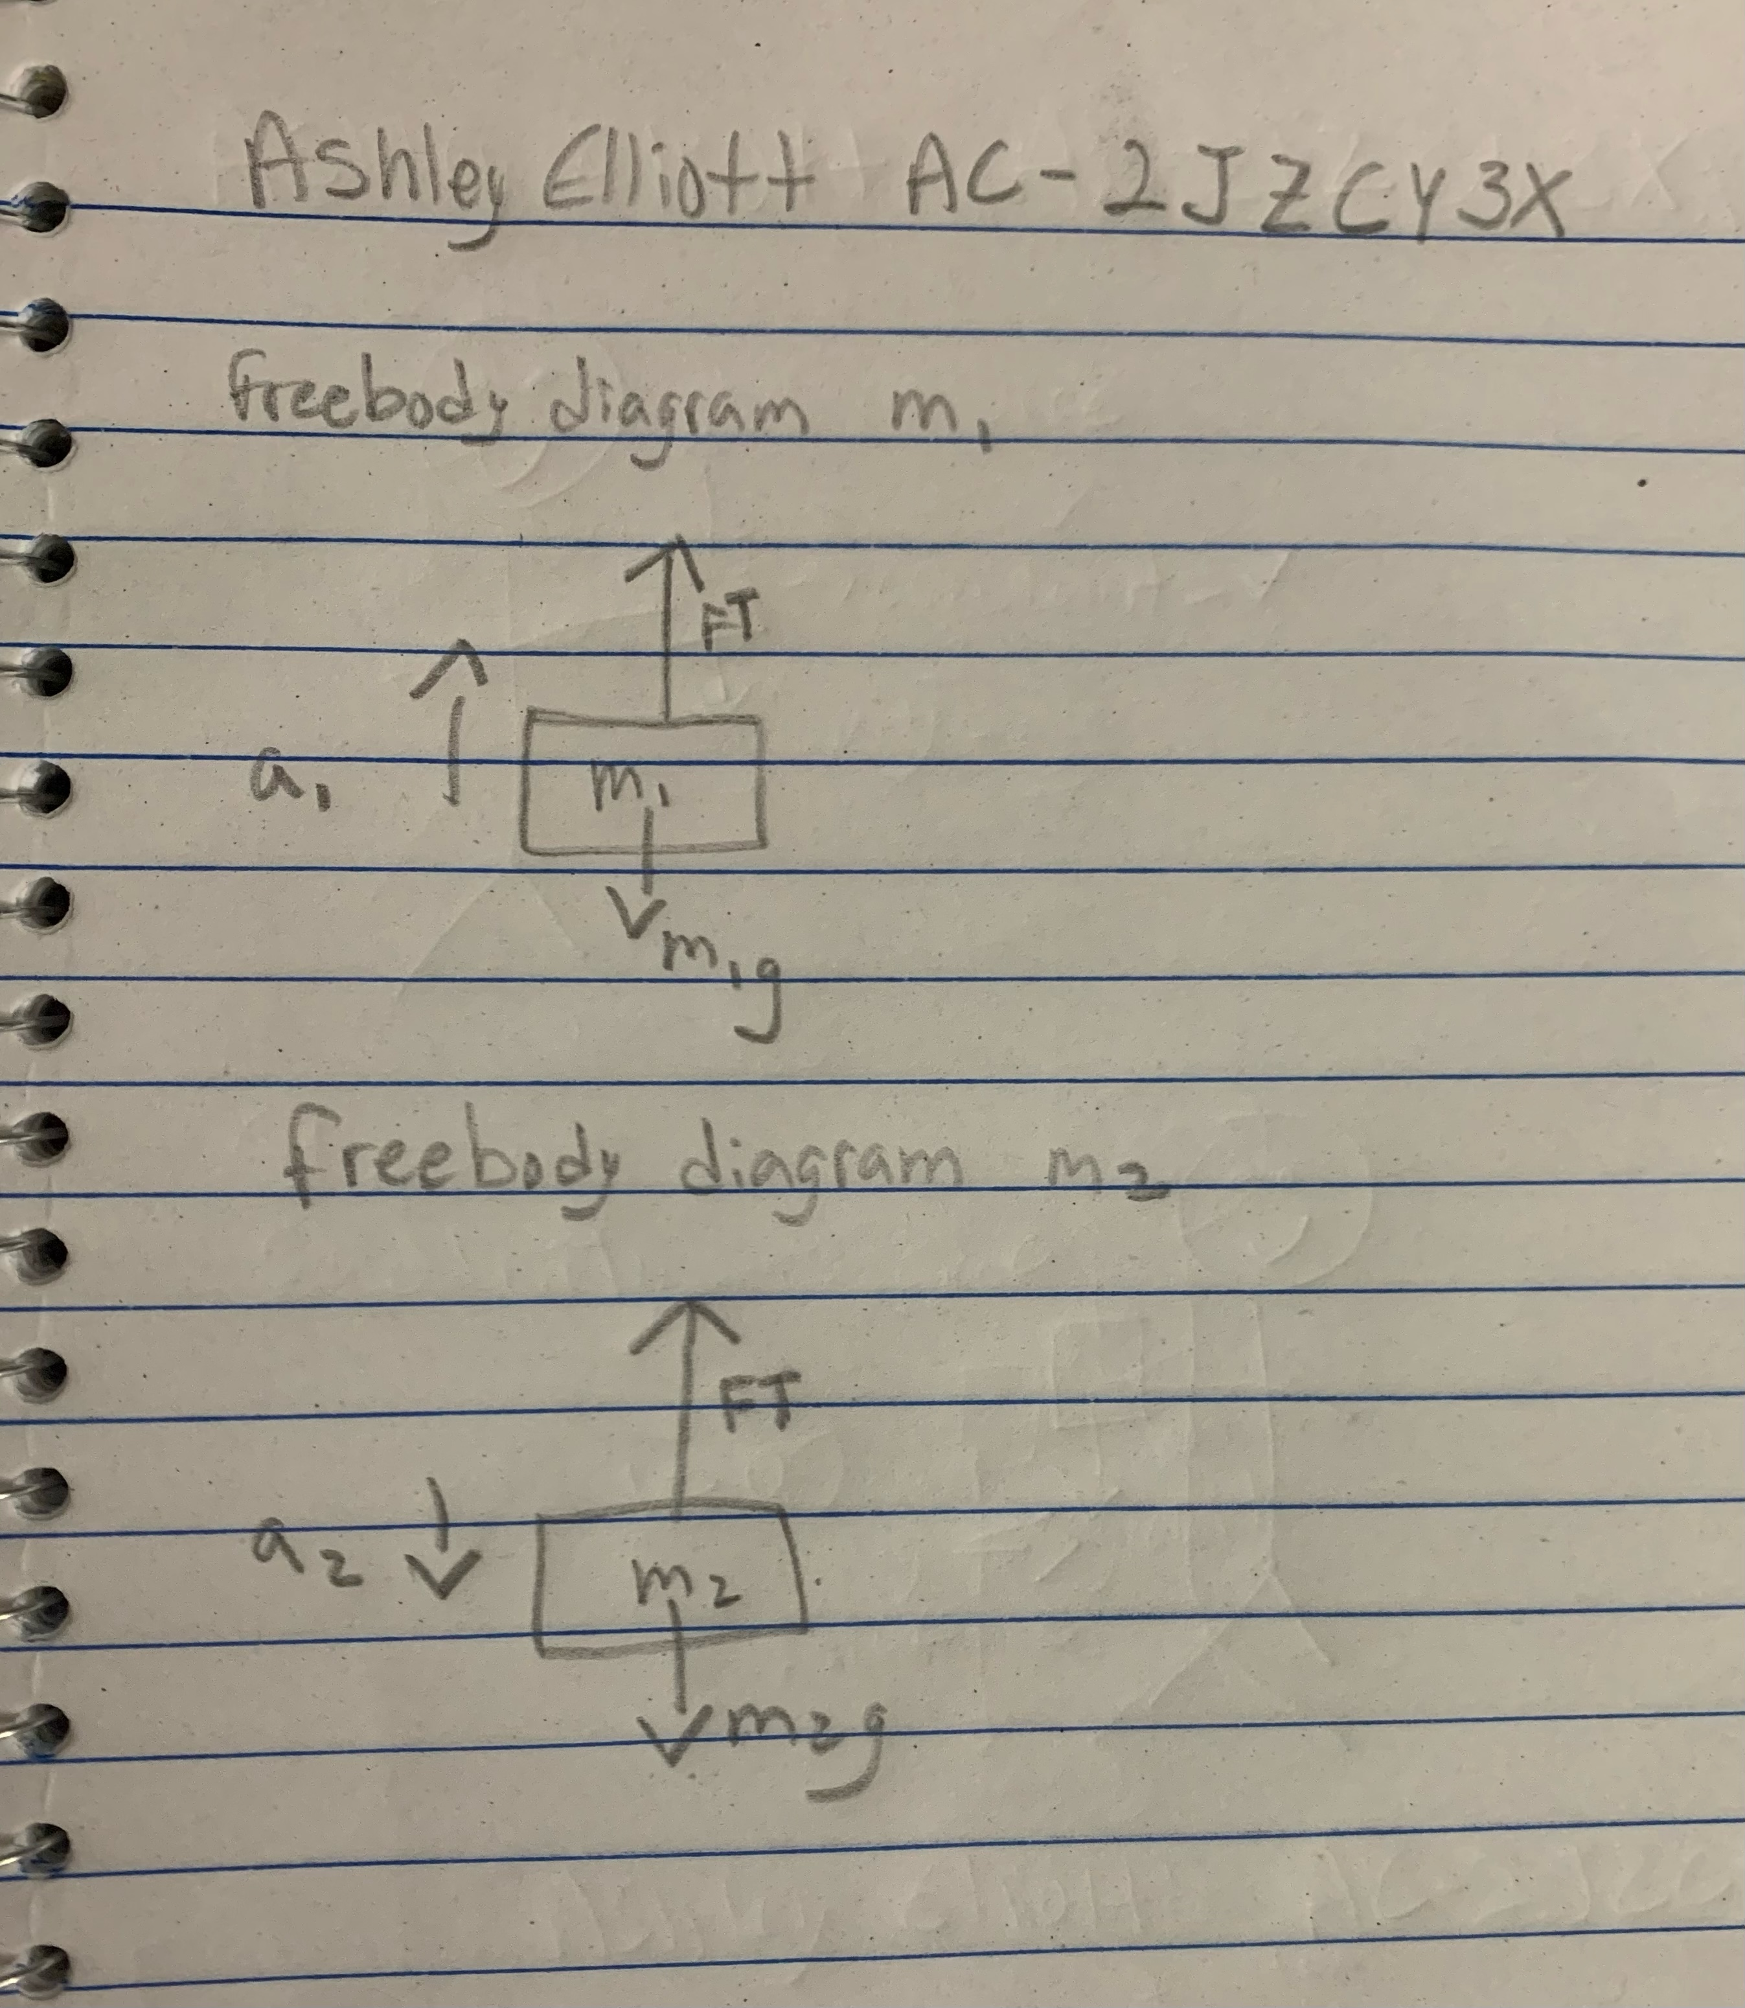

1. Use Newton’s Second Law to write an equation for each of the free body diagrams you drew in Question 2. (Note: Be sure to use the correct signs to agree with your drawings). Solve these four equations for the force of tension (FT). You answer should be in variable form.

**1) M1 a= Ft – fg1 2) M2 a= Ft – Fg2**

1. Set the two resulting expressions for the force of tension equal to one another (as long as the string does not stretch, the magnitude of the acceleration in each equation is the same). Replace Fg1 and Fg2 with M1 and M2, respectively. Solve the resulting equation for *a*. Then, go back to Question 3 and solve for the FT.

**M2 – m1 x g / m1+ m2**

1. Calculate the acceleration for the two sets of data you recorded and compare these values to those obtained by measuring distance and time using percent error. What factors may cause discrepancies between the two values?

**Friction between the string and the pulley as well as added air friction could be some contributing factors to the discrepancies between the two values. Other than air and friction causing discrepancies, user error must also be taken into account.**

1. Calculate the tension in the string for the falling washers. From these two values, and the one where the masses were equal, what trend do you observe in the tension in the string as the acceleration increases?  
   **tension = M1 (g-a1)**